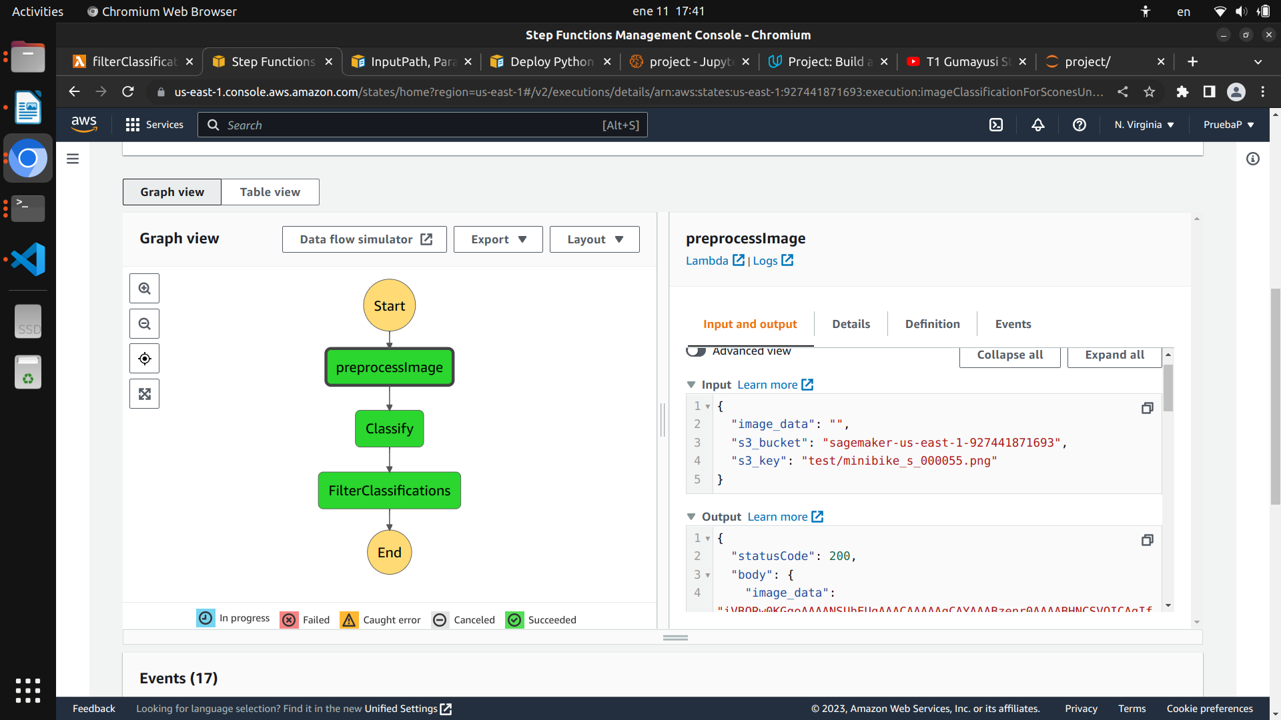
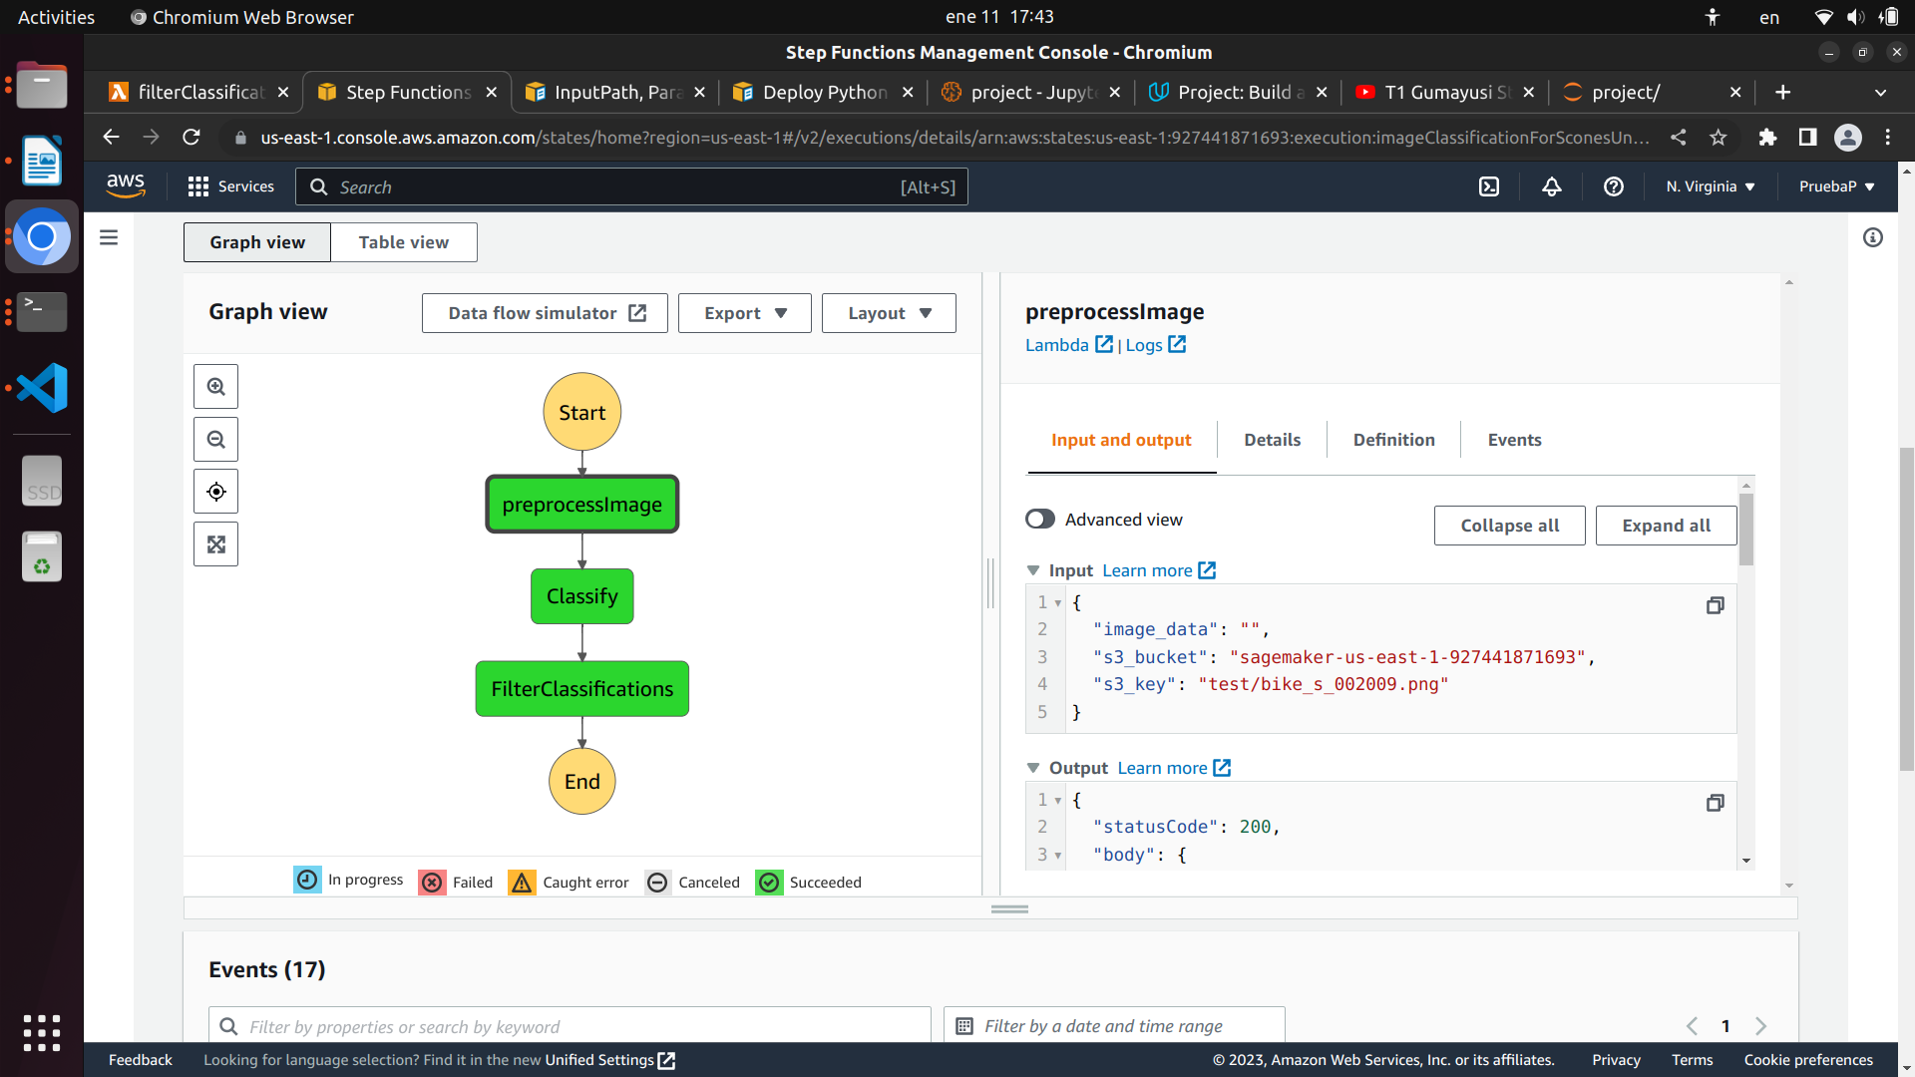
Screenshots depicting successful processing of different images

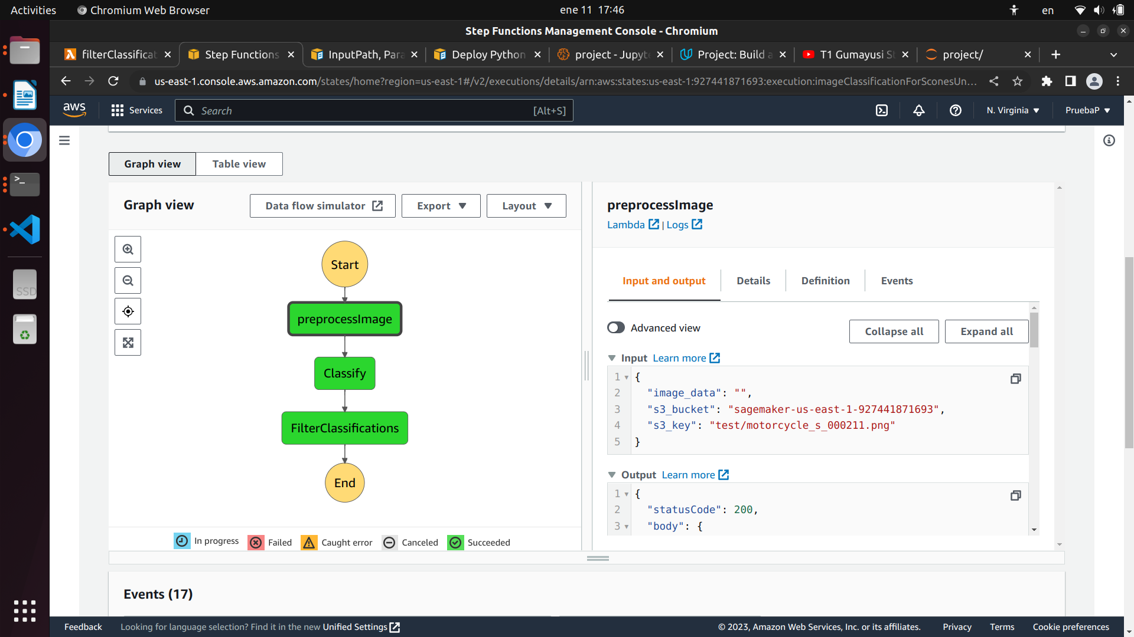
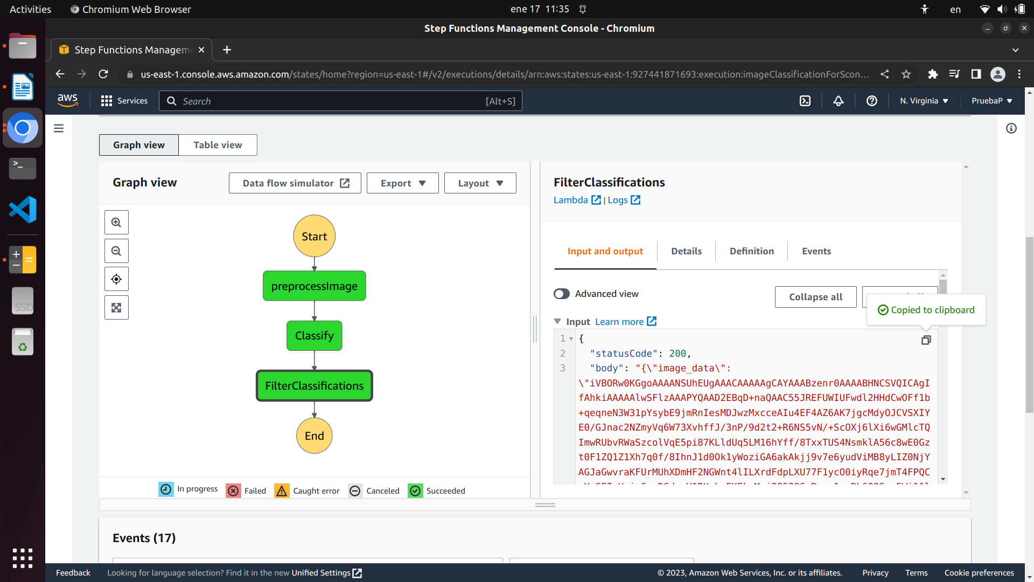

Output of the final step (Filter):
{
"statusCode": 200,
"body": "{\"image_data\": <excluded>, \"s3_bucket\": \"sagemaker-us-east-1-927441871693\", \"s3_key\": \"test/motorcycle_s_000211.png\", \"inferences\": \"[0.0006055505364201963, 0.999394416809082]\"}"
}

TESTING (EXPECTED) FAILURES
To test that the workflow fails when the filter encounters a prediction with a confidence below the THRESHOLD level, I will change the THRESHOLD to 100%. The following images demonstrate what happens when the workflow executes with this THRESHOLD:
